JavaScript
- var let const
var a; //declare
var a=12; //declare and initialize
- in window it will be added
- function scoped
- we can reassign & redeclare again no error will come

let a;
let a=12;
- we cannnot redeclare again
- let b=12;
- let b=23;

const a=12;

- Scope (global, block, functional):
- Global: var a=12; // can be used anywhere in code
- Block: { // can be used within the block
var a=12;
}
- Functional: function hello() { // can be used within the function
let a=12;
}

- Temporal Dead Zone:
  - Js knows that the variable exists but cannot give value
  - Var has no tdz
  - Let has tdz
- console.log(a);
let a=12;
- ReferenceError

- Hoisting:
Eg: var a=12;
- var a= undefined;
- a=12;
- moving declarations on the top
- when we create a variable, it breaks into 2 parts: declaration part will go on the top (var a=undefined) and the initialization part will be at the down (a=12;)
- var can be hoisted and value is undefined
- let can be hoisted and value cannot be set
- const can be hoisted and value cannot be set

EXAMPLES:
- console.log(name);
var name=”Suhas”;
- undefined
- console.log(age);
let age=21;
- ReferenceError (because of tdz)
- var x=1;
{
var x=2;
}
Console.log(x);
- 2
- let a=10;
{
let a=20;
console.log(“Inside:”, a);
}
console.log(“Outside:”, a);
- Inside: 20
- Outside: 10
- If(true) {
Var a=10;
Let b=20;
}
Console.log(a);
Console.log(b);
- 10
- ReferenceError

- Data Types:
- Primitive types:
  - when I copy a value, I get a real copy
  - string, number, Boolean, null, undefined, symbol, bigint
- Reference types:
  - When I copy a value, I don’t get real copy of value but I get reference from parent
  - Arrays [], objects {}, functions ()

- Strings:
  - ‘ ‘ , “ “, ` `
- Number:
  - 123
- Boolean:
  - true, false
- Null:
  - let a = ” ”;
- Undefined:
  - let a;
- Symbol:
  - Unique immutable value
- BigInt:
  - Big integer values
  - MAX_SAFE_INTEGER
- Arrays:
  - let a= [1,2,3,4];
- Objects:
  - let a= {id: “1”, name: “Suhas”};
- Functions:
  - function a() { }

- typeof (quirks)
  - typeof 12 = number
  - typeof “Suhas” = string
  - typeof [] = object
  - typeof {} = object
  - typeof null = object
  - type of NaN = number

- Type Coercion (== vs ===)

- Truthy values and Falsy values:
  - Other than below values all are = true
  - 0 false “” null undefined NaN document.all = false

EXAMPLES:
- true + false => Output: 1
- null + 1 => Output: 1
- 5 + “5” => Output: ‘55’
- !!undefined => Output: false

- Operators:
  - Arithmetic: + - * / % **
  - Comparison: = == === < > <= >= != !== !!
  - Logical: ! && ||
    - &&
      - T T = T
      - T F = F
      - F T = F
      - F F = F
    - ||
      - T T = T
      - T F = T
      - F T = T
      - F F = F
  - Assignment: = += -= *= /= %=
  - Unary: + - ! typeof ++ --
  - Ternary: ? :

- Instanceof:
  - Eg: let a= []; //typeof [] = object
  - a instanceof Array => Output: false
  - a instance of Object => Output: true

EXAMPLES:
- eg:
- a=2;
- a++
- console.log(a); //3
- eg:
- a=2;
- ++a;
- Console.log(a); //3

- Control Flow:
  - If, else, else if
  - Switch case
  - Early return pattern
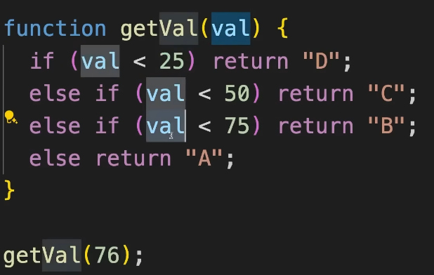

- Loops:
  - for, while, do-while
  - break, continue
  - for-of, forEach for arrays
  - for-in, Object.entries for objects
- For loop:
  - for(start,; end; change) { }
  - for(initialization; condition; iteration) { }
  - 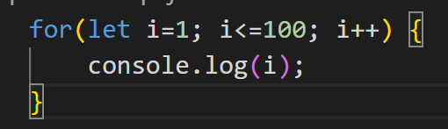
  - // prints 1 to 100

- While loop:
  - used untill a specific condition is true
  - Pattern:
    - start
    - while(end) {
    - change
    - };
    - 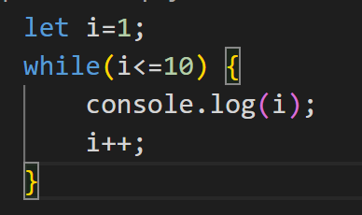
    - // 1 2 3 4 5 6 7 8 9 10

- do-while loop:
  - used to execute the code once before checking the condition is true and will repeat the loop as long as the condition is true
  - Pattern:
    - start
    - do {
    - change // executes first once
    - }
    - while(end);
    - 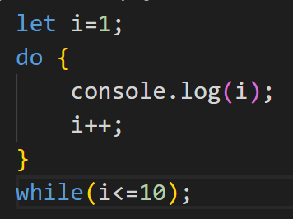
    - // 1 2 3 4 5 6 7 8 9 10

- Break:
  - Breaks the statement and comes out of loop
  - 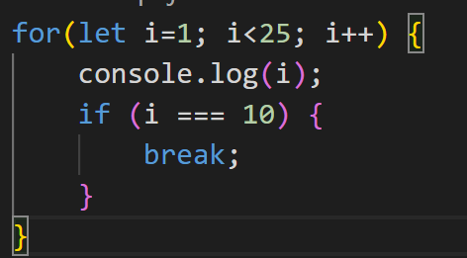
  - // 1 2 3 4 5 6 7 8 9 10

- Continue:

  - skips the current/present iteration in loop
  - 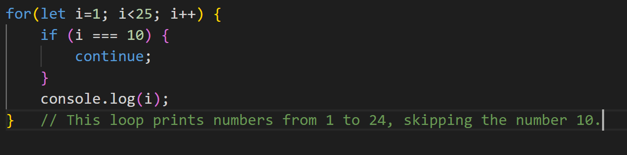

EXAMPLES:
- 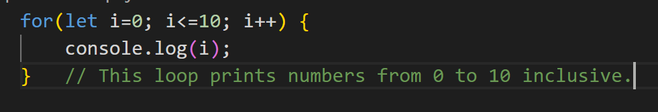
- 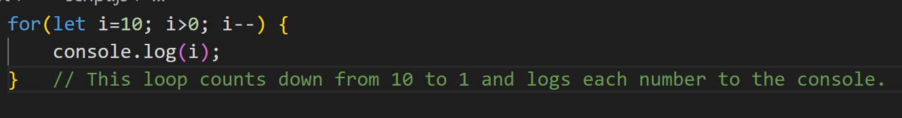
- 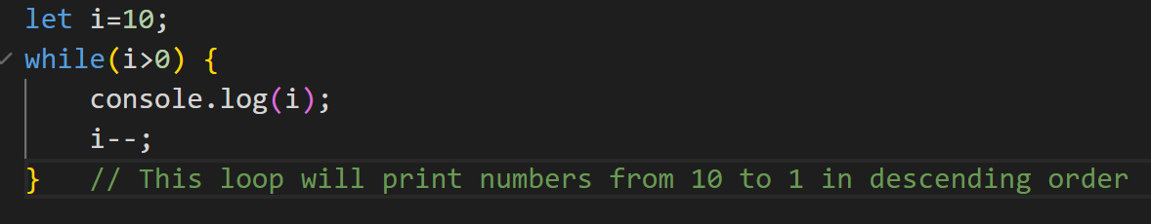
- 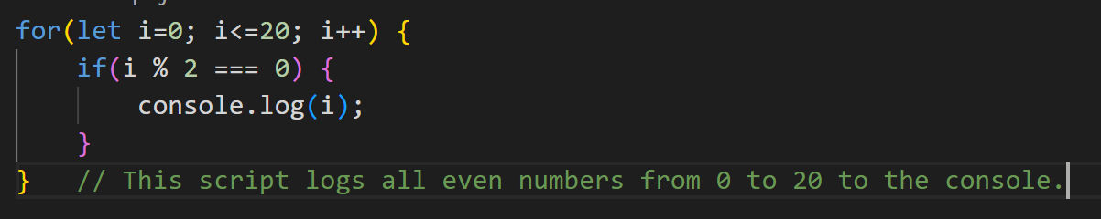
- 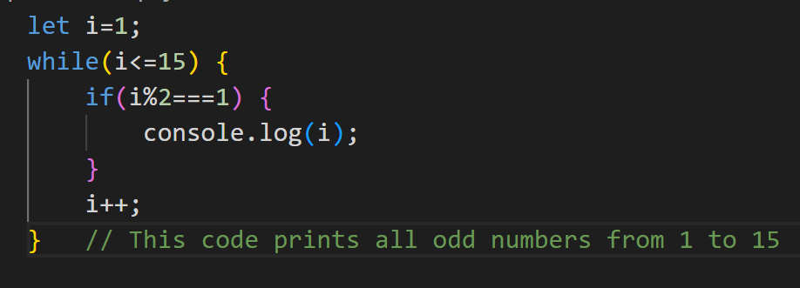
- 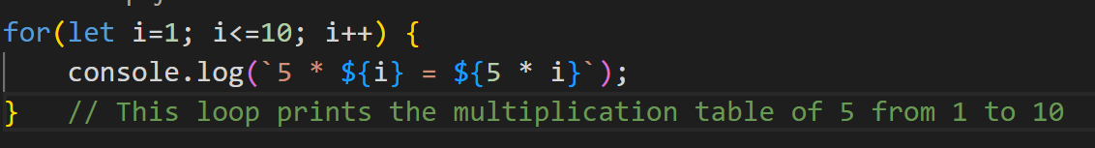
- 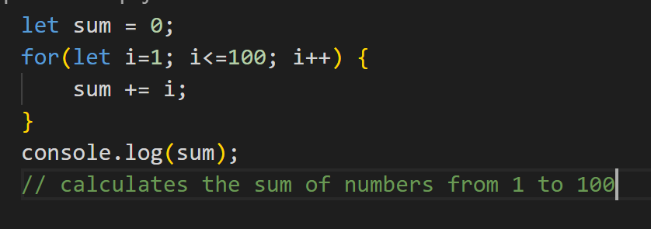
- 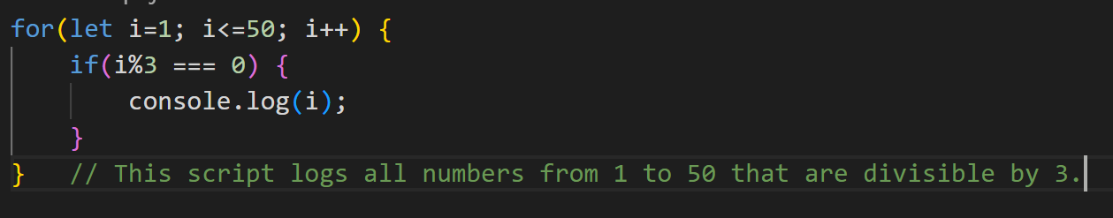
- 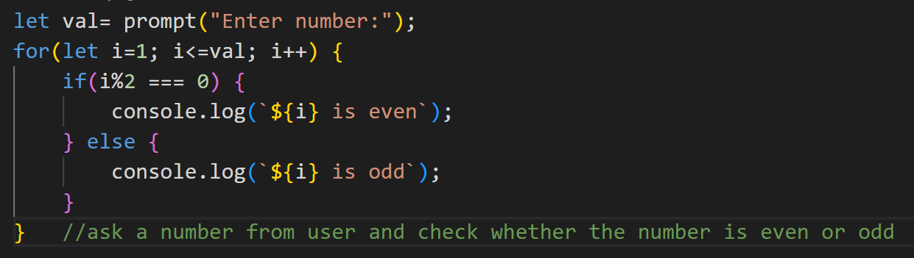
- 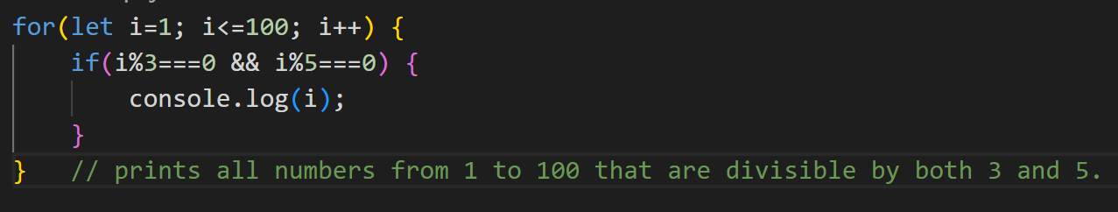
- 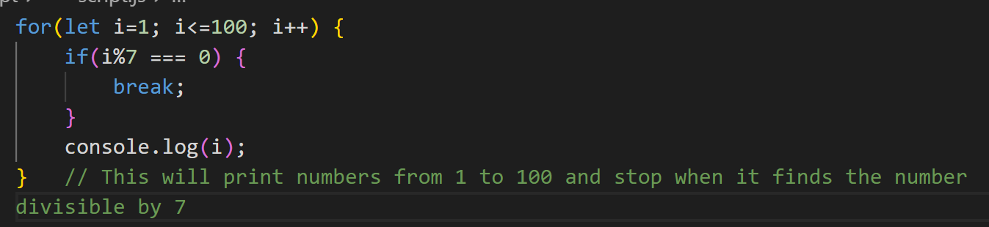
- 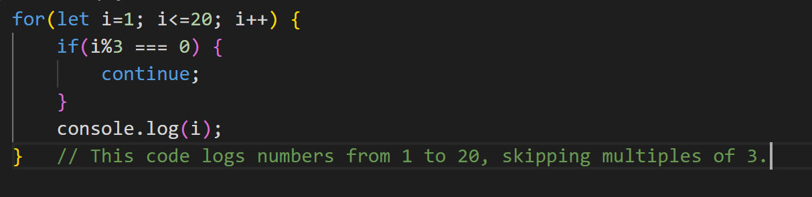
- 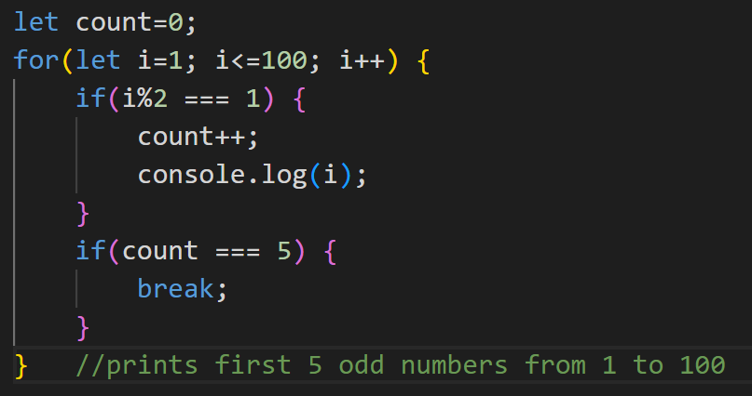

- Functions:
  - function hello() { }
  - hello();
  - 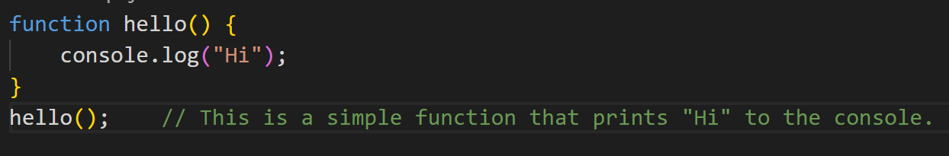
  - 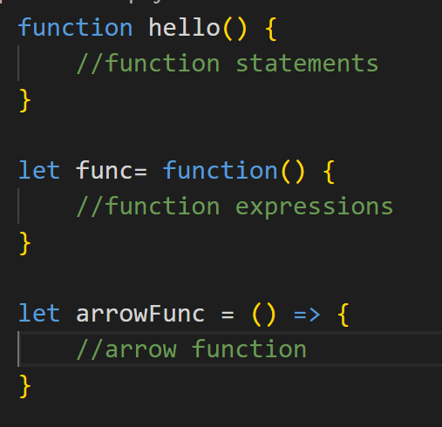
  - 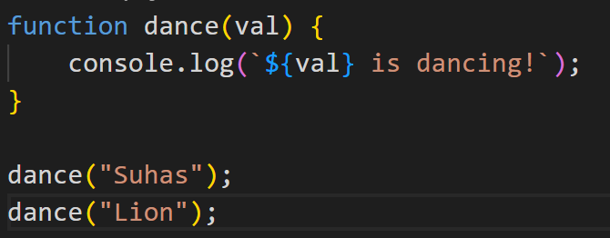
  - 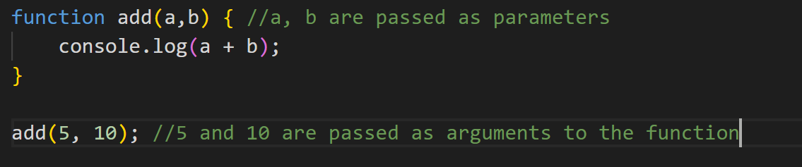

- Default, Rest, Spread parameters:
  - Default parameter:
    - 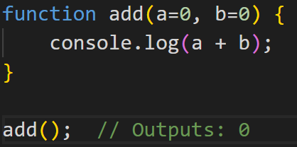

- Rest:
  - 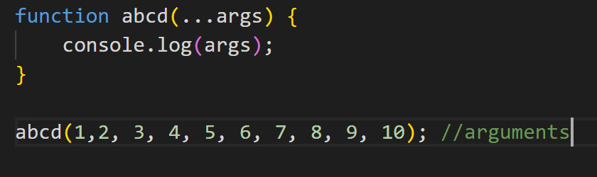

- Return:
  - Returns the value from where it came there only
  - 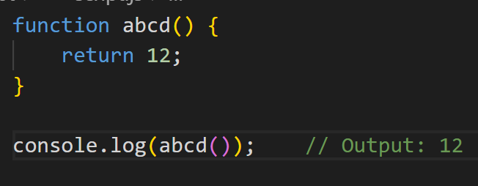

- First Class Functions:
  - Treat functions as values
  - 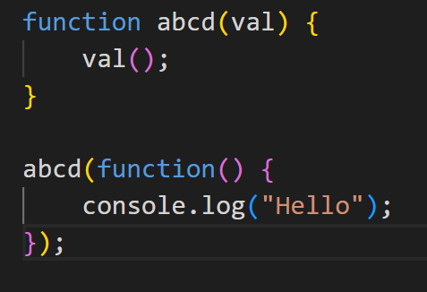

- High Order Functions (HOF):
  - Function where parameter accepts function
  - 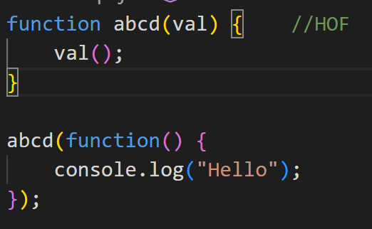
- Pure functions
  - The Function where outside value does not change
  - 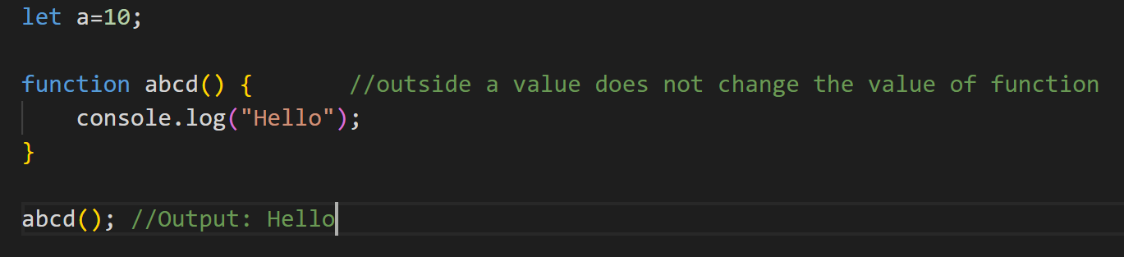

- Impure functions
  - The Function where the outside value changes
  - 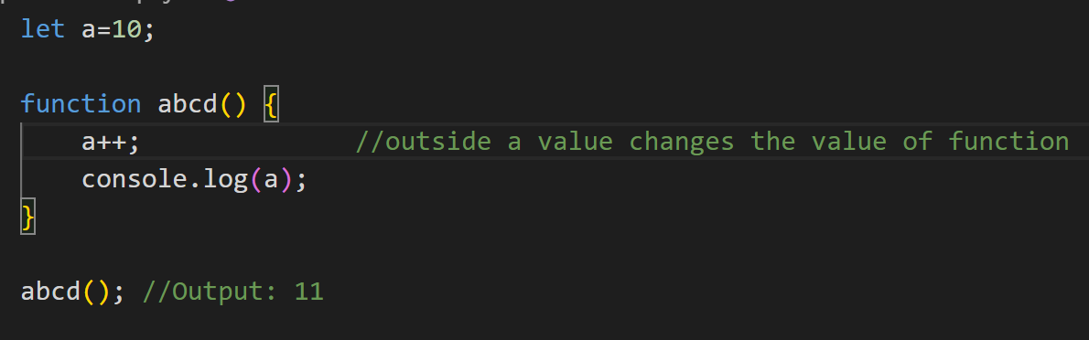

- Closures
  - is a function that returns another function will return a function which has always has access to parent scope function variables
  - 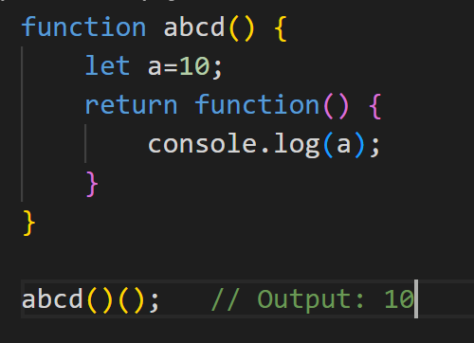

- Lexical Scoping
  - 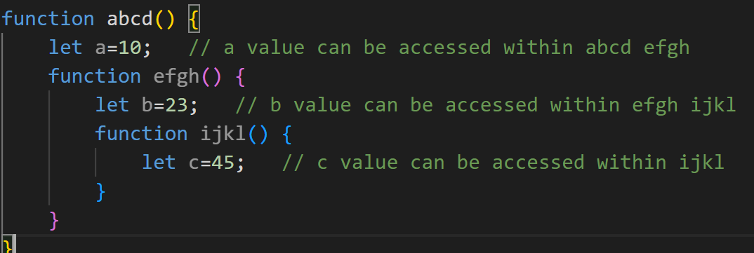

- IIFE (Immediately invoked function expression)
  - 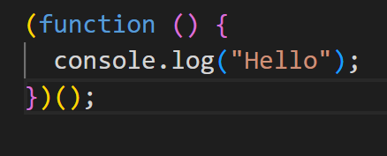

EXAMPLES:
- 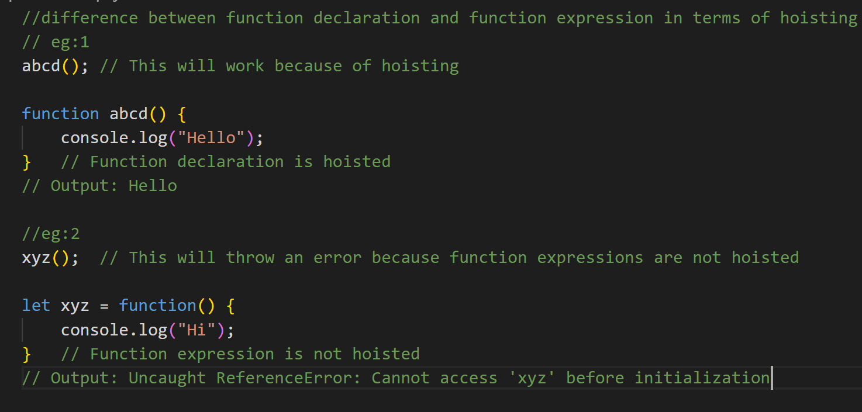
- 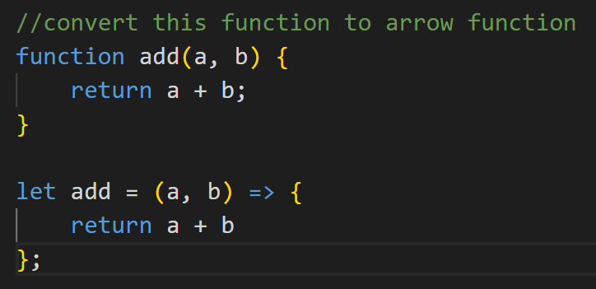
- 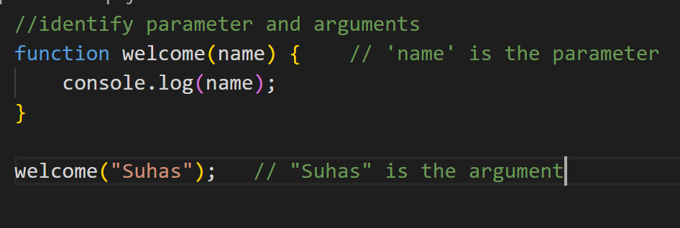
- 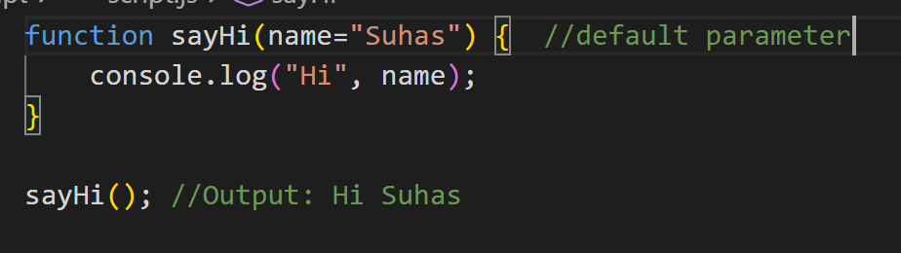
- 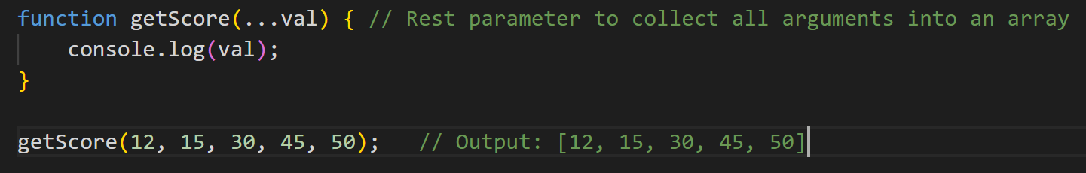
- 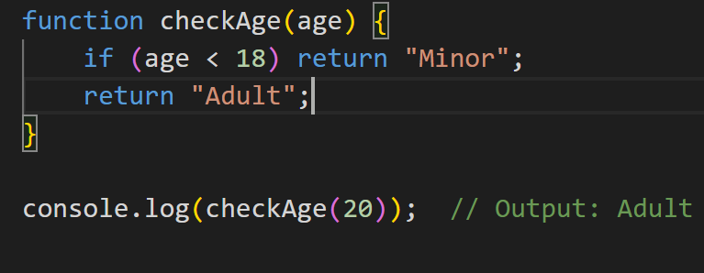

- Arrays
- 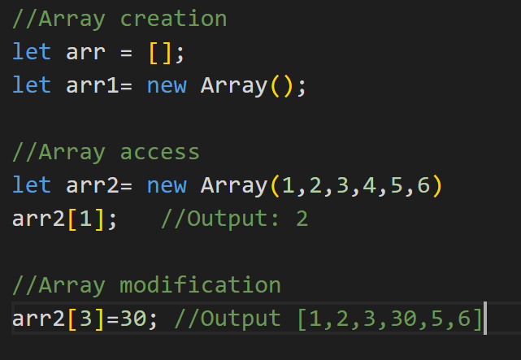
- Methods:
  - Push:
    - Adds new elements to the end of an array, and returns the new length
  - Pop:
    - Removes the last element of an array, and returns that element
  - Unshift:
    - Adds new elements to the beginning of an array, and returns the new length
  - Shift:
    - Removes the first element of an array, and returns that element
  - Splice:
    - Adds or Removes array elements from original array
  - Slice:
    - Selects a part of an array, and returns the new array

  - Reverse:
    - Reverses the order of the elements in an array
  - Sort:
    - Sorts the elements of an array
    - It accepts function
    - arr.sort((a,b) => a-b (ASCENDING ORDER)
    - arr.sort((a,b) => b-a (DESCENDING ORDER)
  - forEach:
    - Calls a function for each array element
    - It accepts function and no return statement
    - 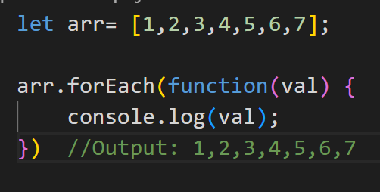
  - Map:
    - Creates a new array with the result of calling a function for each array element
    - It accepts function
    - 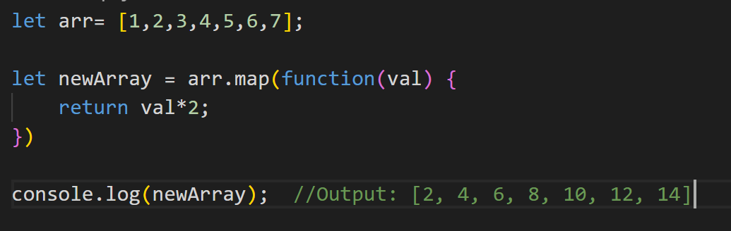
  - Filter:
    - Creates a new array with every element in an array that pass a test
    - It accepts function
    - 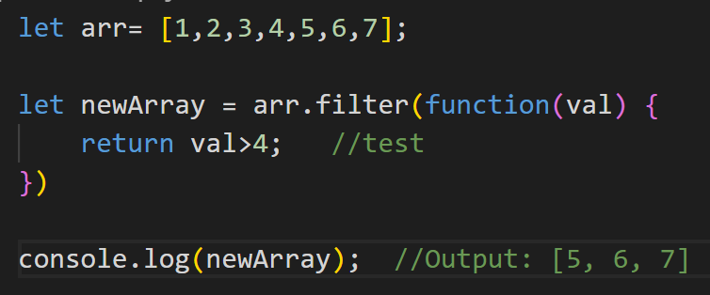

  - Reduce:
    - Reduce the values of an array to a single value (going left-to-right)
    - It accepts function
    - 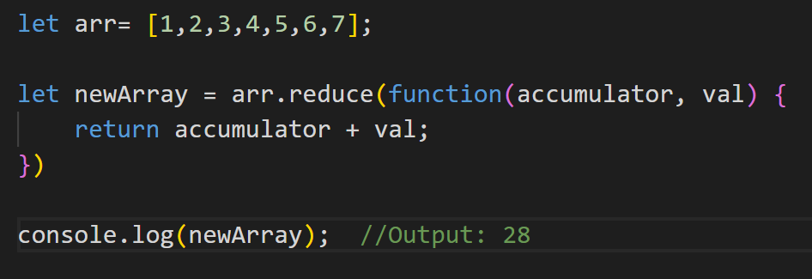

  - Find:
    - Returns the value of the first element in an array that pass a test
  - Some:
    - Checks if any of the elements in an array pass a test
    - Gives true or false values
  - Every:
    - Checks if every element in an array pass a test
    - Gives true or false values

- Destructring
  - 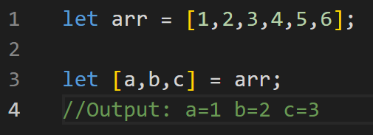

- Spread Operator
  - 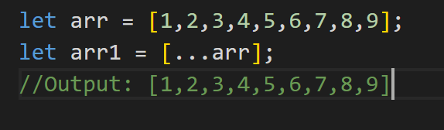

EXAMPLES
- 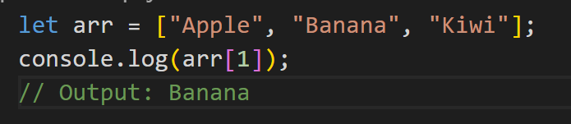
- 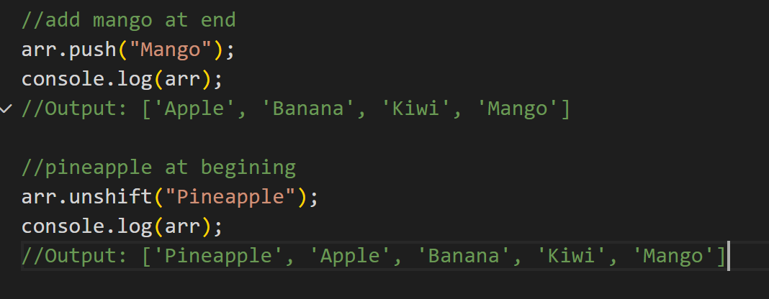
- 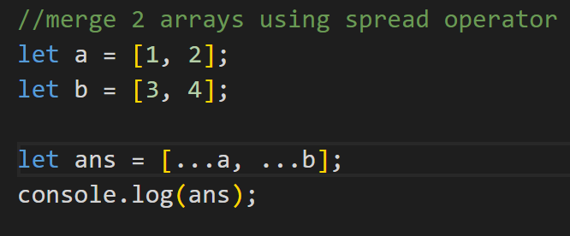
- 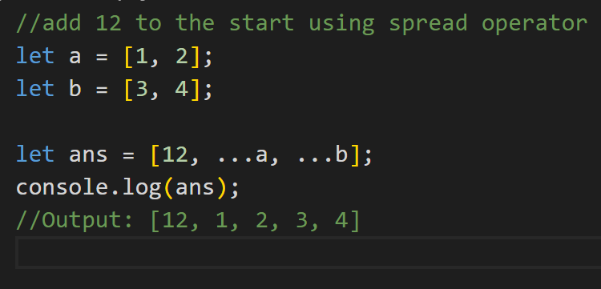

- Objects
  - 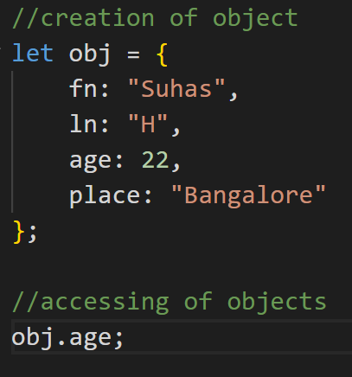
  - 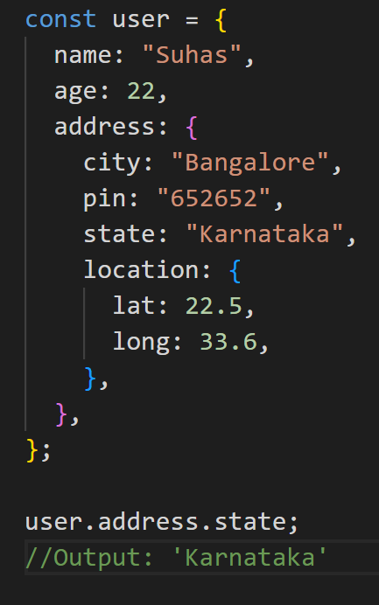
  - Object Destructuring
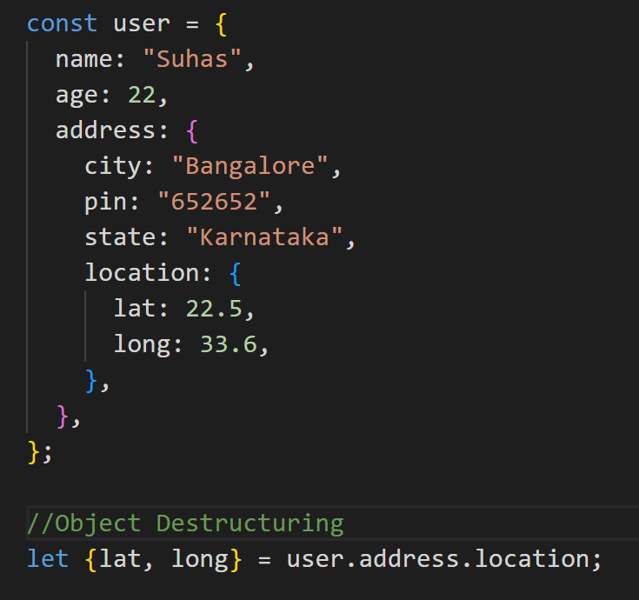
- For-in loop:
  - For let in
  - 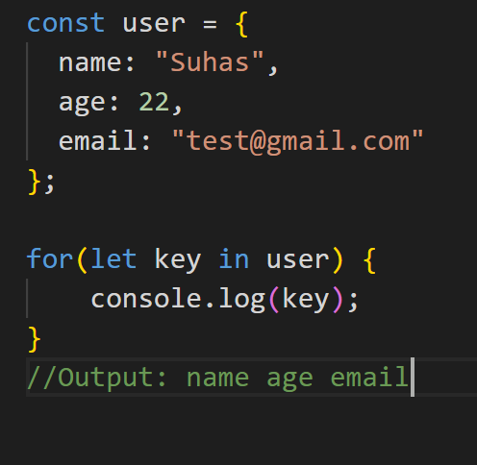
  - 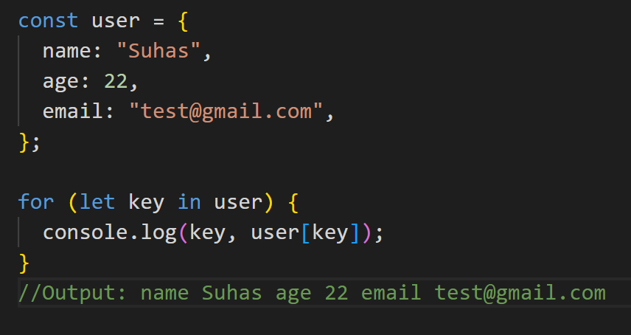

  - Accesing objects (2 ways)
user.age and user[age]

  - Object.keys(user) = all keys will be printed
  - 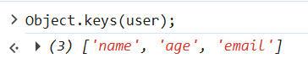

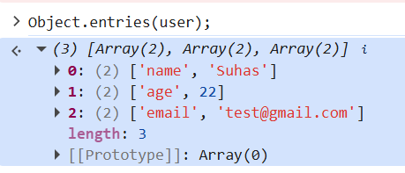

- Spread in Objects
  - 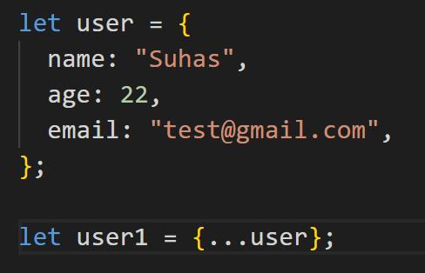

- Object.assign
  - Used as spread operator
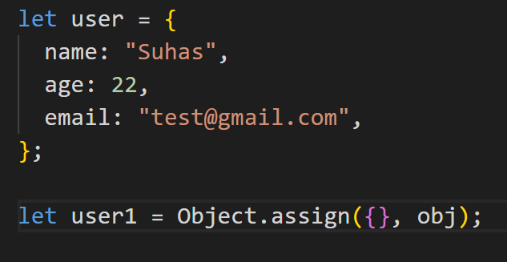
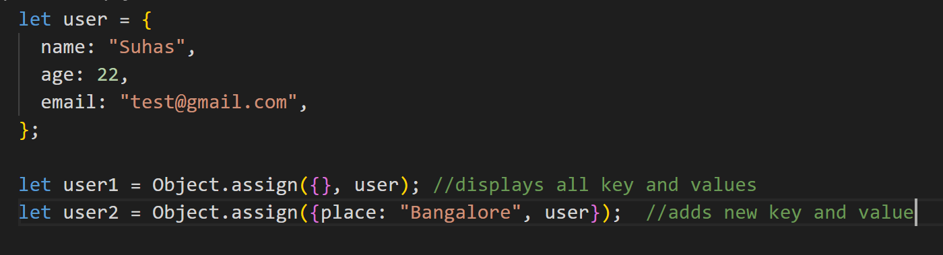
  - Deep Cloning
    - When there is nesting in objects, we cannot use spread to copy or clone
    - We can use JSON.stringify and JSON.parse
    - 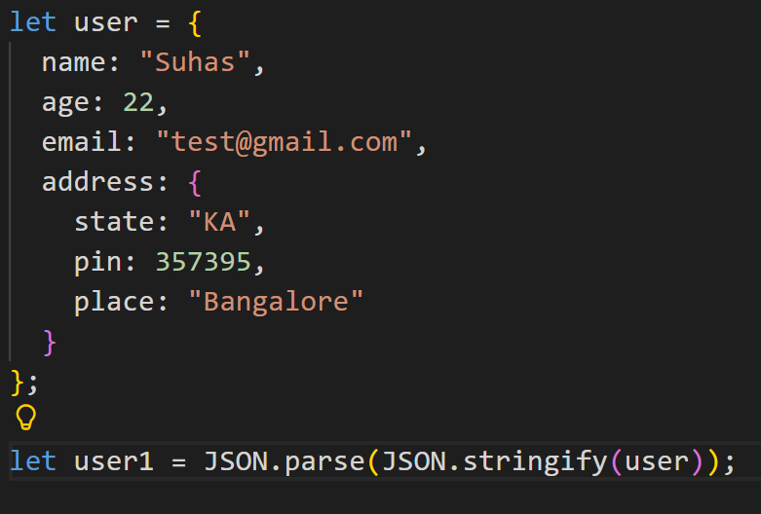
EXAMPLES
  - 
   